CHAPTER 4

4.1 SYSTEM CIRCUIT DIAGRAM AND DESCRIPTION:

CIRCUIT DIAGRAM:
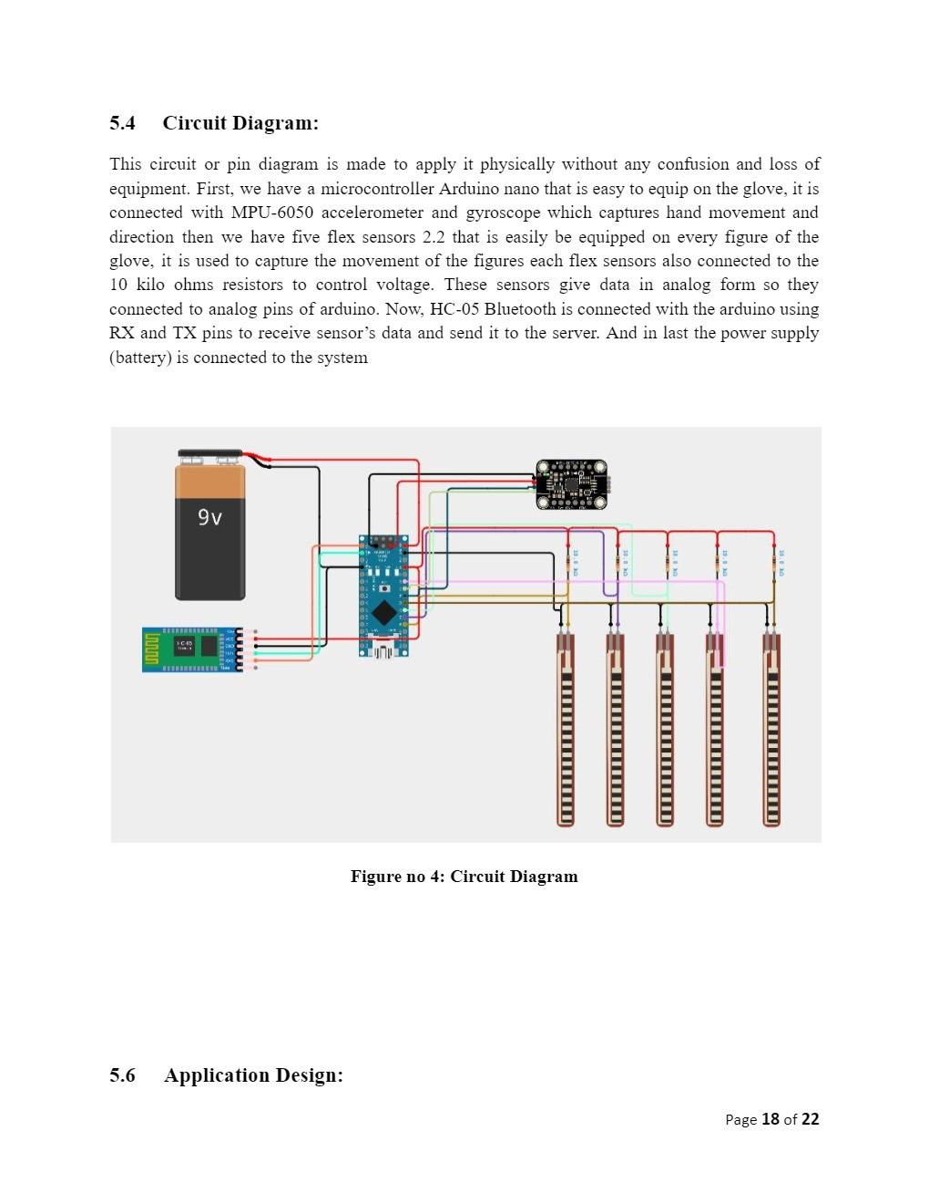
FIGURE 4.1 System Circuit Diagram

DESCRIPTION:
- NodeMCU Microcontroller: The NodeMCU is a popular development board based on the ESP8266 microcontroller. It offers built-in Wi-Fi connectivity and is commonly used for IoT projects. Similar to the Arduino Nano, the NodeMCU serves as the central processing unit for the glove system. It reads data from the sensors and transmits it wirelessly to a receiving device.

- MPU-6050 Accelerometer and Gyroscope: The MPU-6050 sensor remains unchanged. It still functions as both an accelerometer and gyroscope module, providing accurate data on hand orientation and motion. The NodeMCU communicates with the MPU-6050 sensor via its I2C (Inter-Integrated Circuit) interface to retrieve motion data.

- Flex Sensors (2.2): The flex sensors and accompanying 10 kiloohm resistors are still integral to the glove system. Each flex sensor is connected to the NodeMCU's analog input pins, just as before. The NodeMCU reads the varying resistance of the flex sensors to determine finger positions and movements.

- Analog Pins of NodeMCU: The analog output signals from the MPU-6050 sensor and the flex sensors are connected to the analog input pins of the NodeMCU. These pins are capable of reading analog voltages and converting them into digital values for processing by the NodeMCU.

- HC-05 Bluetooth Module: While the HC-05 Bluetooth module is commonly used with Arduino boards, it can also be interfaced with the NodeMCU. The NodeMCU communicates with the HC-05 module via its UART (Universal Asynchronous Receiver-Transmitter) interface, similar to how it communicates with other serial devices. The NodeMCU sends sensor data to the HC-05 module for wireless transmission to a receiving device.

- Power Supply (Battery): The power supply for the glove system remains unchanged. A battery is still used to provide the necessary voltage to operate the NodeMCU, sensors, and Bluetooth module. The choice of battery depends on factors such as capacity, size, and desired operating time.

4.2 COMPONENTS CIRCUIT DIAGRAMS & DESCRIPTIONS

4.2.2 Flex Sensor

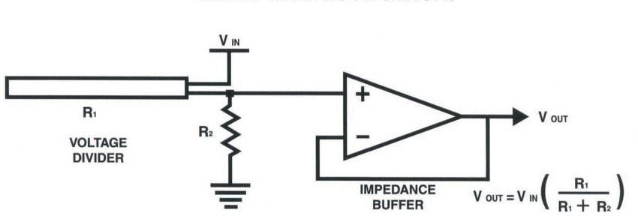
FIGURE 4.2 Flex Sensor

DESCRIPTION:
A flex sensor is a type of sensor that detects bending or flexing in a physical object, typically made of a flexible material such as plastic or rubber. It consists of a thin strip or ribbon of conductive material that changes resistance when bent. As the sensor is flexed, the spacing between particles within the material changes, altering its electrical resistance.

Flex sensors are commonly used in applications where monitoring the degree of bend or curvature is important. For example, they are frequently employed in wearable technology, robotics, and human-machine interfaces to detect and track finger movements, hand gestures, or the bending of joints.

The operation of a flex sensor is based on the principle of resistive sensing. When the sensor is in a relaxed or neutral position, its resistance remains relatively constant. However, as it is bent or flexed, the resistance changes proportionally to the degree of deformation. This change in resistance can be measured using electronic circuits and interpreted to determine the angle or extent of bending.

Flex sensors are available in various lengths and configurations to suit different applications. They are often integrated into wearable devices, such as gloves or sleeves, where they can accurately capture the movement of fingers or limbs. Additionally, they can be easily interfaced with microcontrollers or other electronic components to provide real-time feedback or control signals.

Overall, flex sensors offer a versatile and reliable solution for detecting bending or flexing in a wide range of applications, enabling precise monitoring and control of physical movements.

4.2.2 MPU-6050
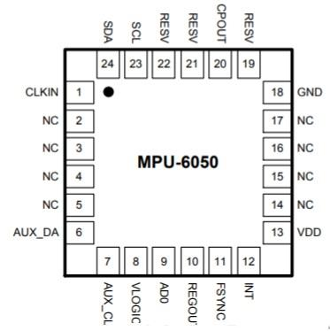

FIGURE 4.3 MPU-6050

DESCRIPTION:

The MPU-6050 is a commonly used Inertial Measurement Unit (IMU) sensor module. It combines a gyroscope and an accelerometer in a single package, allowing it to measure both angular velocity (rotational motion) and linear acceleration. Here's a breakdown of its main features and components:
1. Gyroscope: The gyroscope in the MPU-6050 measures the rate of angular rotation around three orthogonal axes (X, Y, and Z). It provides data about the rotational movement of the sensor.
2. Accelerometer: The accelerometer measures the acceleration force acting on the sensor along the same three axes (X, Y, and Z). It provides data about the linear acceleration of the sensor.
3. Six Degrees of Freedom (6DoF): With both gyroscope and accelerometer, the MPU-6050 provides six degrees of freedom, enabling it to capture a wide range of motion data in three-dimensional space.
4. Digital Motion Processor (DMP): The MPU-6050 includes a built-in Digital Motion Processor, which offloads some of the sensor fusion computations from the host microcontroller. This feature helps in reducing the computational load on the main processor and simplifies motion tracking algorithms.
5. Interface: The MPU-6050 typically interfaces with microcontrollers or other computing devices using standard communication protocols such as I2C (Inter-Integrated Circuit) or SPI (Serial Peripheral Interface). This makes it easy to integrate into various electronic projects.

4.2.3 Bluetooth HC-05
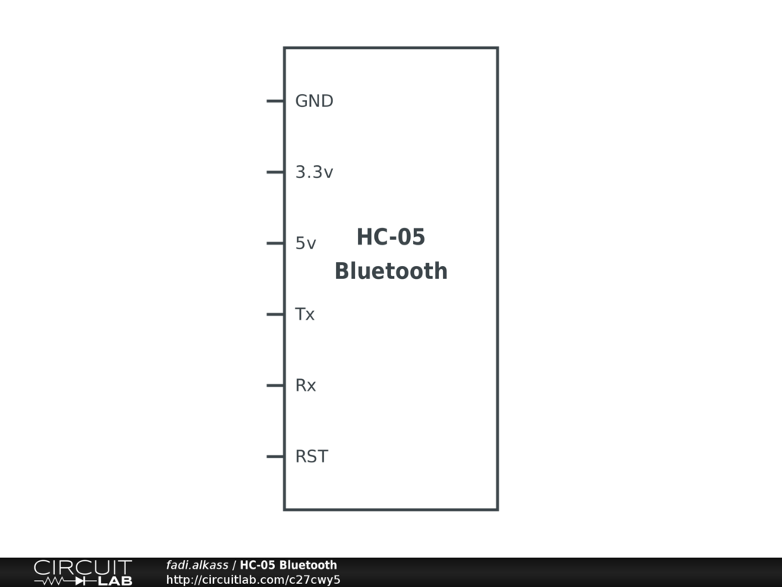
FIGURE 4.4 Bluetooth
DESCRIPTION:
The HC-05 is a Bluetooth module for wireless communication in electronics projects. It supports Bluetooth version 2.0 + EDR, offers both Master and Slave modes, and is controlled using AT commands. It has a range of around 10 meters and is commonly used in various applications like data logging, remote control systems, and IoT projects.4.2.4 NODEMCU:
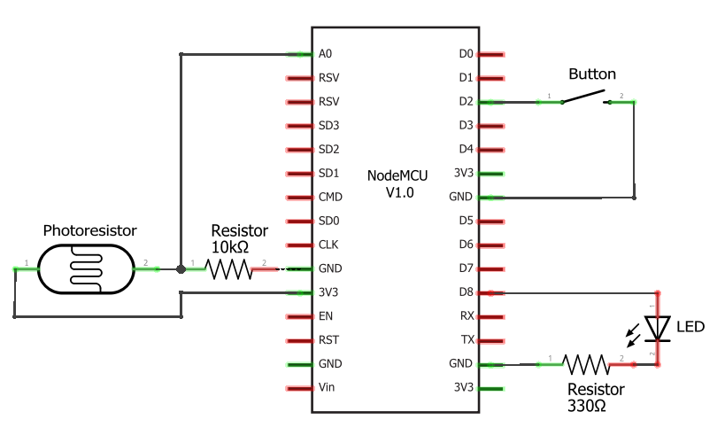
FIGURE 4.5 Node MCU

DESCRIPTION:
The NodeMCU is a versatile open-source development board that has gained significant popularity in the maker and IoT (Internet of Things) communities. It is based on the ESP8266 microcontroller and offers built-in Wi-Fi connectivity, making it ideal for projects that require wireless communication and internet connectivity.

Here are some key features and characteristics of the NodeMCU:

1. ESP8266 Microcontroller: The NodeMCU is powered by the ESP8266 microcontroller, which features a 32-bit Tensilica processor running at up to 80 MHz. Despite its small size and low cost, the ESP8266 offers impressive processing power and capabilities, including Wi-Fi connectivity, GPIO (General Purpose Input/Output) pins, ADC (Analog-to-Digital Converter), SPI (Serial Peripheral Interface), I2C (Inter-Integrated Circuit), and UART (Universal Asynchronous Receiver-Transmitter) interfaces.

2. Built-in Wi-Fi: One of the standout features of the NodeMCU is its built-in Wi-Fi connectivity, which allows it to connect to wireless networks and communicate with other devices over the internet. This capability makes the NodeMCU well-suited for IoT applications, remote monitoring, home automation, and wireless sensor networks.

3. Arduino IDE Compatibility: The NodeMCU can be programmed using the Arduino IDE (Integrated Development Environment), making it accessible to a wide range of developers and hobbyists familiar with the Arduino platform. Arduino libraries and code examples can be easily adapted for use with the NodeMCU, simplifying the development process.

4. Lua Scripting Support: In addition to Arduino programming, the NodeMCU also supports Lua scripting, thanks to its NodeMCU firmware. Lua is a lightweight scripting language that is well-suited for IoT applications and rapid prototyping. Users can write Lua scripts to control the NodeMCU's GPIO pins, interact with sensors, and implement networking functionality.

5. GPIO Pins: The NodeMCU features a series of GPIO pins that can be configured as digital inputs or outputs, analog inputs, or specialized interfaces such as SPI and I2C. These pins allow the NodeMCU to interface with various sensors, actuators, displays, and other electronic components, enabling a wide range of project possibilities.

6. Compact Size and Low Cost: The NodeMCU is compact in size, making it easy to integrate into projects with limited space constraints. Furthermore, it is available at a relatively low cost, making it an affordable option for hobbyists, students, and professionals alike.

Overall, the NodeMCU offers a powerful and cost-effective platform for developing IoT projects and wireless applications. Its combination of ESP8266 microcontroller, built-in Wi-Fi connectivity, Arduino compatibility, and GPIO pins make it a versatile tool for makers and developers seeking to create connected devices and smart solutions.

4.2.5 9V BATTERY:

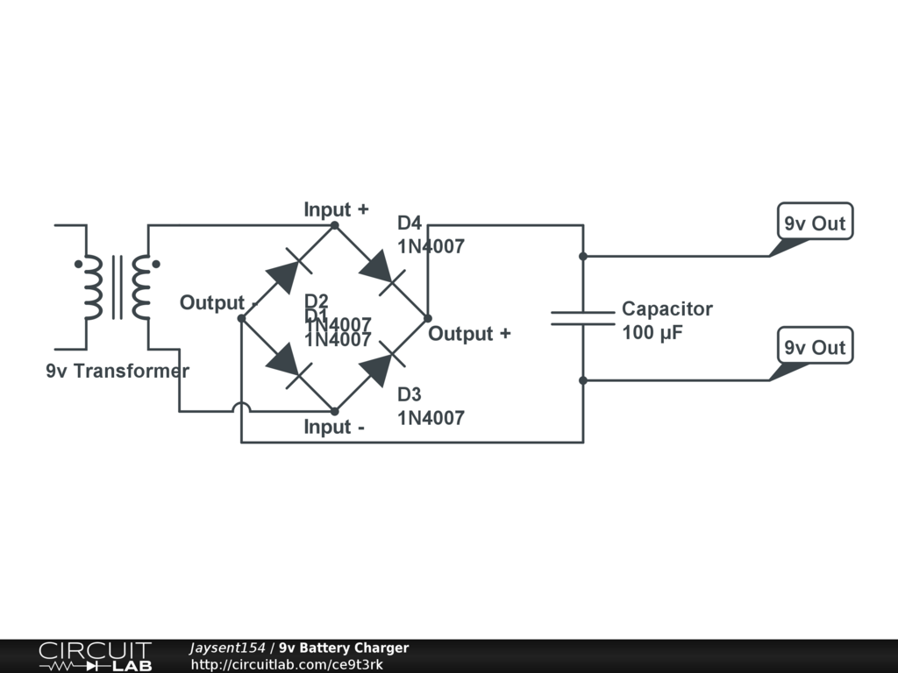
FIGURE 4.6

DESCRIPTION:
A 9V battery is a rectangular power source with a nominal voltage of 9 volts. It's commonly used in electronic devices that require higher voltage levels and is available in disposable and rechargeable versions.

